6PM Tech Strategy Template Standard

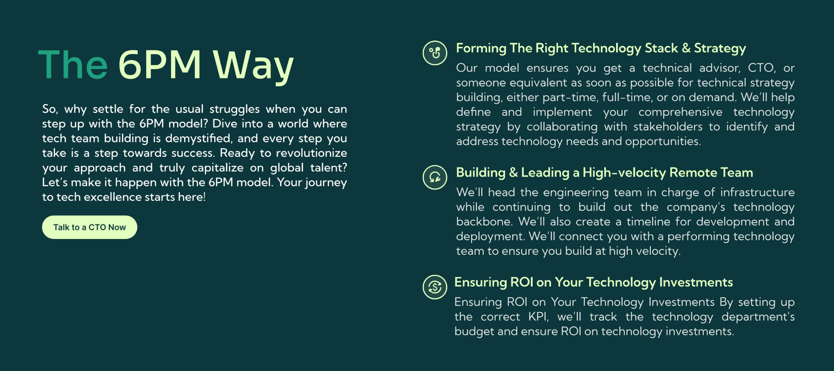

[Stratup_Name] Technology Strategy
Updated: Jan 1, 2025 | Updated By: [Your_Name]

Tech Strategy
Purpose: Define your technological innovation and how it positions your company competitively.
Importance: Essential for articulating your unique tech proposition and strategic direction.
Estimated Completion Time: 30-45 minutes.

SL | Item | Write Here | Sample [Remove this]
1 | Core Innovation Strategy | Describe the primary innovation in tech that sets you apart. | Developing a proprietary AI algorithm to personalize user experiences.
2 | Strategic Growth Framework | Outline your growth strategy through technology. | Scale the user base by integrating scalable cloud services and adopting automation.
3 | Competitive Tech Positioning | Detail how technology will position your company in the market. | Leveraging cutting-edge blockchain technology to enhance data security, appealing to privacy-conscious consumers.

Tech Objective
Purpose: Establish clear, measurable objectives for your technology strategy.
Importance: Crucial for setting specific targets and milestones that guide your tech development efforts.
Estimated Completion Time: 20-30 minutes.

SL | Item | Write Here | Sample [Remove this]
1 | Comprehensive Tech Goals | What is your ultimate tech goal for this project? | Build a robust, scalable platform that supports 100,000 concurrent users.
2 | Milestones for the Next Quarter | Short-term tech milestones within three months. | Complete the MVP with core features and begin user testing.
3 | Mid-Term Tech Achievements | Mid-term tech objectives to be achieved within six months. | Implement additional features based on initial user feedback and prepare for a beta launch.
4 | Long-Term Tech Vision | Long-term goals for the end of the year. | Fully launch the platform with full features and achieve operational stability.

Tech Budget (12 Months)
Purpose: Allocate financial resources effectively across your technology strategy.
Importance: Critical for ensuring that financial planning aligns with your tech goals and the operational needs of your tech department.
Estimated Completion Time: 25-35 minutes.

SL | Item | Write Here | Sample [Remove this]
1 | Overall Tech Budget for 12 Months | Estimate the total budget for technology needs over the next year. | $500,000
2 | Budget Allocation for Tech Leadership | Allocation for hiring or consulting with technology leadership. | $120,000
3 | Development Team Budget | Funds are reserved for developers or external agencies. | $250,000.
4 | Software and Infrastructure Budget | Budget for necessary software licenses, server costs, and tools. | $130,000

Tech Tools
Purpose: Outline the tools that will be used to build and support your technology infrastructure.
Importance: Ensures that the team has the necessary software and systems to achieve tech objectives efficiently.
Estimated Completion Time: 20 minutes.

SL | Item | Write Here | Sample [Remove this]
1 | Communication Tools | List the tools used for team communication. | Slack, Zoom, Microsoft Teams
2 | Development Environments | Tools for software development and testing. | GitHub, GitLab, Bitbucket
3 | Design and UX Tools | Software used for designing user interfaces. | Adobe XD, Sketch, Figma
4 | Project Management Tools | Platforms to track progress and manage tasks. | Jira, Asana, Trello
5 | Database Management | Tools for managing and storing data. | MySQL, PostgreSQL, MongoDB
6 | Server Management | Services for hosting and server management. | AWS, Google Cloud, Azure

Tech Stack
Purpose: Specify the core technologies that will be used to develop your product.
Importance: Defines the technical foundation of your product, crucial for ensuring compatibility and scalability.
Estimated Completion Time: 30 minutes.

SL | Item | Write Here | Sample [Remove this]
1 | Front-End Technology | Technologies used for the client side. | ReactJS, AngularJS, VueJS
2 | Back-End Technology | Technologies used for server-side logic. | Node.js, Python, Ruby on Rails
3 | Database Systems | Database technologies for data management. | MongoDB, SQL Server, Oracle
4 | Hosting Services | Platforms for deploying and hosting applications. | AWS Elastic Beanstalk, Heroku, DigitalOcean

Software Testing Strategy
Purpose: Define the methodologies and tools for testing your technology.
Importance: Ensures your technology's reliability, security, and functionality before it goes live.
Estimated Completion Time: 20-30 minutes.

SL | Item | Write Here | Sample [Remove this]
1 | Unit Testing | Approaches for testing individual components. | JUnit for Java, Mocha for JavaScript
2 | Integration Testing | Techniques for testing interactions between modules. | TestRail, Postman for API testing
3 | System Testing | Strategies for full system evaluations. | Selenium, Katalon Studio
4 | Performance Testing | Methods to evaluate the performance and scalability. | LoadRunner, Apache JMeter

Conclusion

Ensuring a Future-Proof Technology Strategy
As you complete this template, you establish a foundation not only for current tech initiatives but also for future innovations and expansions. This document is designed to grow with your business, adaptable to new challenges and opportunities that arise as your technology evolves. It's more than just a plan—it's a dynamic framework for continuous technological leadership and strategic foresight.

