Financial Strategy Template

Editable text:
Name of your organization
example@email.com
example.com

Table Of Contents

Executive Summary 2
[Complete this section last] 2
Problems & Solutions 3
Target Market 4
Market Size & Segments 4
Competition 5
Current Alternatives 5
Our Advantages 5
Execution 8
Marketing Plan 8
Sales Plan 10
Operations 11
Locations & Facilities 11
Technology 11
Equipment & Tools 11
Timeline 13
Key Metrics 15
Customer Acquisition Cost (CAC) 15
Customer Retention Rate (CRR) 15
Lifetime Value (LTV) 15
Monthly Active Users (MAU) 15
Customer Churn Rate (CCR) 15
Average Revenue Per User (ARPU) 15
Monthly Recurring Revenue (MRR) 16
Return on Investment (ROI) 16
Company 17
Overview 17
Management Team 19
Advisors 19
Expenses by Month 21
Net Profit (or Loss) by Year 22
Financing 23
Use of Funds 23
Sources of Funds 23
Financial Forecast 24
Have Questions? 34

All the texts and images used in this document are for sample purposes only

Executive Summary

[Complete this section last]
Problem Summary
- What problem do you solve for your customers?

Solution Summary
- How do you solve the problems of your customers?
Market
- Who are your target customers or market segments?
Competition
- Who will your customers also consider?
Why Us?
- Why should the customers choose your company over the competitors?

Problems & Solutions
Problems of Our Target Customers
- What do your customers need? Do they need a better product, a cheaper product, a service that is more convenient, or easy to access?
Our Solutions to Their Problems
- Write in detail how you are going to solve the tech problems of your target customers.

Target Market

Market Size & Segments
Describe your key customers – who they are and what their key attributes are. Use the template below to segment your Tech Startup’s target market:

Demographics | Psychographics | Firm-Based | Behavioral
Age: | Personal Values: | Market size: | Frequency of Usage:
Gender: | Attitude: | Location: | Brand Loyalty:
Ethnicity: | Aspirations: | Business Performance: | Product Benefits:
Education Level: | Lifestyle: | Structure: | Occasion:
Geographic Area:

[This is just a reference: remove before publishing]
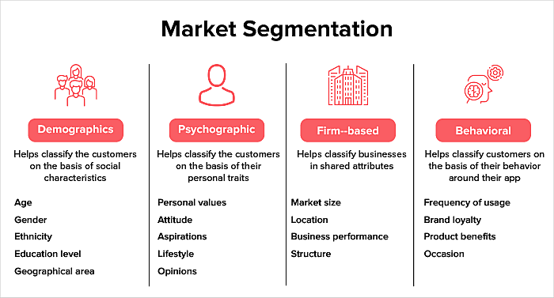

Competition

Current Alternatives
- What products and services are people using instead of yours?

Our Advantages
- How are you better than your competitors?

Use the templates below to conduct a competitive analysis of the tech industry:

- Competitive Analysis
- SWOT Analysis
- Porter’s Five Forces Analysis

- Competitive Analysis

 | Your Company | Competitor 1 | Competitor 2 | Competitor 3 | Competitor 4
 | Use company data to fill up this row | Use competitor data to fill up this section | Use competitor data to fill up this section | Use competitor data to fill up this section | Use competitor data to fill up this section
Products/Services
Financial Resources
Market Share/Growth
Strategies
Business Model
Strengths
Weaknesses
SWOT Analysis

Strengths | Weaknesses
What are the strengths of your organization in the market?  Examples:  - Marketing/technical expertise  - Good location  - Established marketing/distribution channels  - Good reputation | What are the weaknesses of your organization in the market?  Examples:  - Bad/unknown reputation  - Product/service is not differentiated  - Lack of funding  - Limitation of resources
Opportunities | Threats
What are the opportunities your organization has in the market?  Examples:  - Uncompetitive niche  - High demand for the product  - Existing tech/marketing/etc team  - Low barrier to entry | What are the threats your organization has in the market?  Examples:  - New competitors  - Price wars  - Change in customer attitude

Porter’s Five Forces Analysis

Bargaining Power of Suppliers | Threat of New Entrants | Competition | Threat of Substitutes | Bargaining Power of Buyers
High or Low? | High or Low? | High or Low? | High or Low? | High or Low?
Examine the control of software and hardware suppliers over pricing and terms.  This can vary significantly in the tech startup ecosystem depending on the uniqueness and availability of the technology or services required. | Examine how easy or difficult it is for new companies to enter and compete with established Tech Businesses. | Examine the level of competition among existing organizations in the tech industry. | Identify potential substitutes for your tech startup's product/service. This includes alternative technologies, solutions, or platforms that could fulfill the same need. | Determine the power of customers to influence pricing and terms.
Example:  - Control of software and hardware suppliers over pricing and terms  - Availability of unique technology or services | Example:  - How easy is it for new businesses of a similar nature to enter the market?  - Your company’s expertise in a particular area  - Cost advantage  - Technology protection  - Patent protection | Example:  - Number of competitors in the market  - Differences in the quality of the product  - How loyal are the customers to your product? | Example:  - Price your competitors are offering  - Switching cost of product | Example:  - Differences between competitors  - How sensitive is the price  - Number of customers you serve

Execution

Marketing Plan
- How are you informing your target customers about your product or service? Through digital ads, content marketing, or email marketing, or direct contact?

Use the template below to create a killer marketing plan for your tech startup business:

Define Your Marketing Strategy | Pick Your Marketing Mix | Choose Your External Communication | What is Your Marketing Message? | Pick Your Marketing Channels | Measure Your Marketing Plan
Write your goal #1 | Product  Examples:  - Quality  - Features  - Branding  - Availability  - Warranty  - Variants  - Customer Support | What online channels will you choose?  Website, app, social media? | Which main problem does your product/service solve in the tech industry? | Email marketing | Audience report
Write your goal #2 | Promotion  Examples:  - Direct marketing  - Advertising  - PR | What offline channels will you choose?  Store, magazine advertising, word of mouth? |  | Content marketing | Acquisition report
 | Price  Examples:  - Market positioning  - Discounts  - Payment methods |  |  | Digital marketing | Behavior report
 | Place  Examples:  - Locations  - Logistics  - Distribution channels (website, wholesale, retail, etc) |  |  | Social media marketing | Conversion report
People

Example:

- Employees
- Founders
- Company culture
- Training
Process

Example:

- Delivery
- Complaint handling
- Customer service
- R&D
Physical Evidence

Example:

- Office or store
- Equipment
- Packaging
- Interior design
- Hygiene
- Music, smell, etc.

Sales Plan
If your company relies on sales people to close sales deals, you need a sales plan. Your sales plan should explain how you convert people who express interest in your tech product or service into paying customers.

Create a sales plan with the help of the templates shared below:

 | First 30 Days | First 60 Days | First 90 Days
Focus
Goals
Priorities
Performance Goals
Metrics of Success

[This is just a reference: remove before publishing]
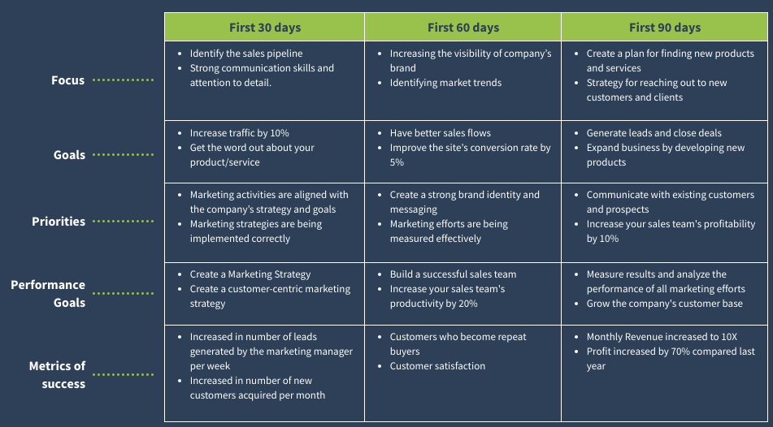

Operations

Locations & Facilities
Talk about your office, store locations, manufacturing plants, storage facilities, etc. Does the space you have enough to meet your current and future operational needs?

Technology
Describe any important software, hardware, or other information technology that you use now or later. Some examples are QuickBooks for accounting, Slack for workplace communication, and Asana for project management.

Equipment & Tools
List any specialty equipment that you have or plan to acquire for your business. This is an important component of the business plan.



Timeline
List the key milestones of your tech startup business by following the example below:

Milestone | Timeline | Tasks | Description
Phase 1 | Jan | Business Planning | Examples:  - Pick your niche  Find out how to monetize your business  - Research product/service you want to offer
Phase 2 | Feb | Development | Examples:  - Set up an office  - Hire employees  - R&D  - Setup the business model
Phase 3 | Mar | Marketing | Examples:  - Put your brand, product or service out there  - Use social media, magazine advertising, television advertising, etc.
Phase 4 | April | Build Your Audience | Examples:  - Engage with the audience through Google Ads, Facebook Ads, or directly  - Provide assistance through customer support
Phase 5 | May | Build Your Network | Examples:  - Find and collaborate with leaders in the tech niche
Phase 6 | June | Modifications | Examples:  - Analyze feedback  - Alter product/service based on feedback from stakeholders  - A/B testing
Phase 7 | July | Extension | Examples:  - Extend products, audience, customers, partners, and income



Key Metrics
Here are some KPIs to measure how successful your tech business is performing. Measure these metrics every 3 to 6 months to monitor progress.

Customer Acquisition Cost (CAC)
measures how much an organization spends to acquire new customers.

- CAC = Total marketing campaign costs related to acquisition/Total customers acquired

Customer Retention Rate (CRR)
is a metric that measures the percentage of customers a company retains in a specific time period.

- CRR = CRR = ((E-N)/S) x 100

S = Your total customer at the beginning of that time frame
E = Your total number of customers at the end of the time period
N = The total number of new customers you gained within the time period

Lifetime Value (LTV)
is an estimate of the average revenue that a customer will generate throughout their lifespan as a customer.

- Customer lifetime value = customer value x average customer lifespan

Monthly Active Users (MAU)
are the number of unique users who engage with a product or a website within the last month.

- Add together the number of unique users from each day. Then, divide that value by 30 days.

Customer Churn Rate (CCR)
is the percentage of customers that have stopped making purchases.

- Divide the number of customers lost over a quarter by the number of customers you had at the beginning of the quarter.

Average Revenue Per User (ARPU)
measures the amount of money that a company can expect to generate from an individual customer.

- Divide the business's total revenue by its total number of users.

Monthly Recurring Revenue (MRR)
measures the predictable recurring income generated from customers on a monthly basis.

- Multiply the number of monthly subscribers by the average revenue per user (ARPU).

Return on Investment (ROI)
is a performance measure used to evaluate the efficiency or profitability of an investment.

- ROI = Cost of investment/Current value of investment−Cost of investment
​
​



Company

Overview
- Is your company a sole proprietorship? Or a partnership, such as a limited-liability corporation (LLC) or a partnership (LLP)? Or a nonprofit organization?

Give a nice overview of your company in the template below. The reference is on the next page.

Company Profile
Management
Finances
Products & Services
Business Model
Market
Risk Management

[This is just a reference: remove before publishing]
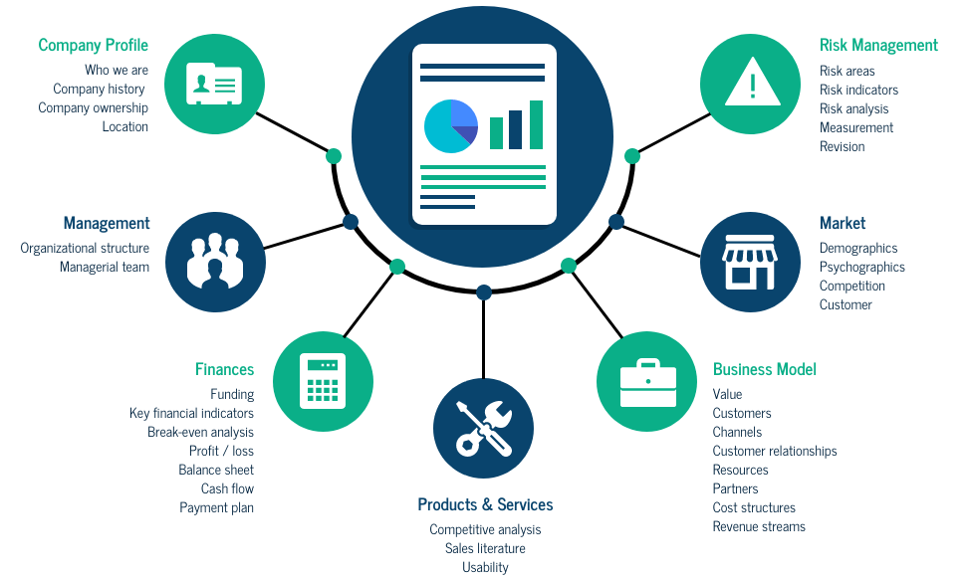

Management Team
List the members of the management team, including yourself. Describe each person’s skills and experience and what they will be doing for the company.

 | Name | Role
Management Member 1
Management Member 2
Management Member 3
Management Member 4

Advisors
Describe any mentors, investors, former professors, industry experts, small-business counselors, or others who can help you as a business owner.

Advisor 1 | [name of the advisor] | [state what they are known for]
Advisor 2 | [name of the advisor] | [state what they are known for]
Advisor 3 | [name of the advisor] | [state what they are known for]



Expenses by Month
Make a chart like this to show your projected expenses:

[This is just an image for reference]
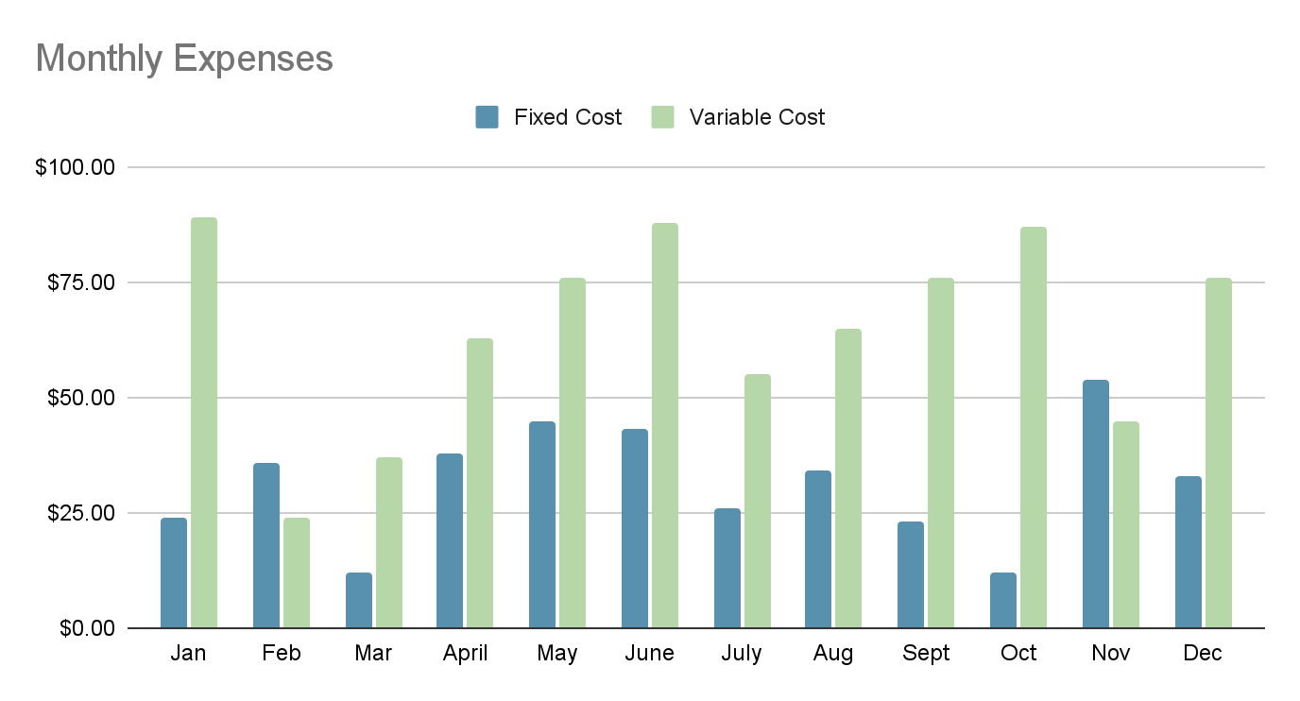

Net Profit (or Loss) by Year
Make a chart like this to show your projected expenses:

[This is just an image for reference]

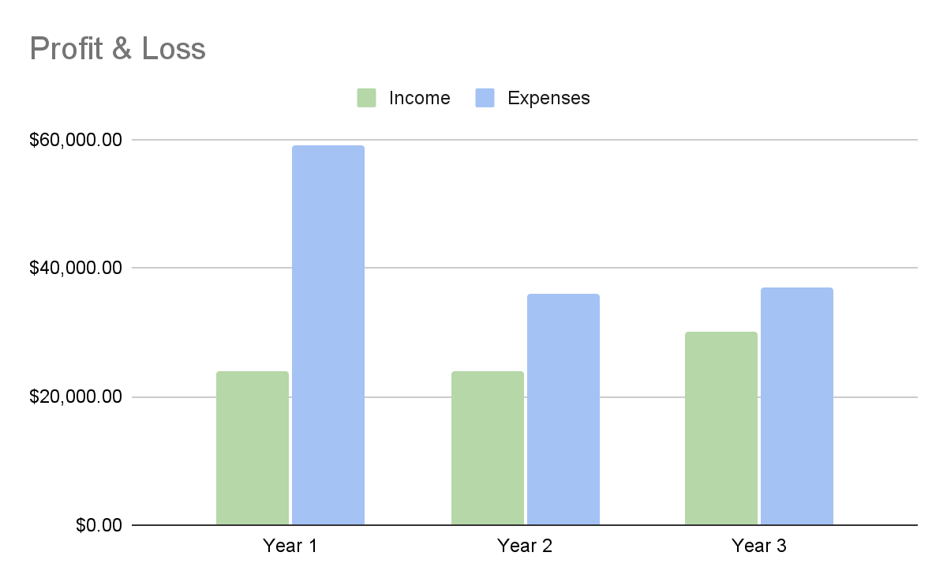

Financing

Use of Funds
Explain what you hope to accomplish over the next year with the investment, loans, and other financing options available to you.

Sources of Funds
What types of funds are you using as capital? Some examples are personal loans, business loans, and equity investments.



Financial Forecast
Question: How much do you plan to sell next year? What is your financial plan for the next year?

Use the templates provided below to create your own Financial Forecasts on Google Spreadsheets or Microsoft Excel:
- Business Startup Cost Template
- Projected Profit & Loss Template
- Projected Balance Sheet Template
- Cash Flow Statement Template
- Monthly Profit & Loss Template
- Annual Profit & Loss Template
- Monthly Balance Sheet Template
- Annual Balance Sheet Template

- Business Startup Cost Template

Business Name
Funding |  | Estimated | Actual | Under/Over
Investor Funding
Owner 1
Owner 2
Other
 | Total Investment
Loans
Bank Loan 1
Bank Loan 2
Non-Bank Loan 1
 | Total Loans
Other Funding
Grant 1
Other
 | Total Other Funding
Total Funding
Costs |  | Estimated | Actual | Under/Over
Fixed Cost
Opening advertising
Basic website
Basic development
Premise downpayment
Business License
Decorating
Equipment
Lease security deposit
Legal fees
Internet
Furniture
Fixture
Security system
Starting inventory
Tools & supplies
Vehicle
 | Total Fixed Cost
Average Monthly Cost
Advertising
Business Insurance
Vehicle insurance
Wages
Equipment lease
Raw materials
Health insurance
Internet
Legal fees
Loan/credit card interest
Miscellaneous fees
Mortgage
Payroll tax
Security system
Utility
 | Total Average Monthly Cost x No. of Months
 | Total Monthly Cost
Total Funding
Surplus/Deficit

- Projected Profit & Loss Template
 | FY2023 | FY2024 | FY2025
Revenue
Direct Costs
Gross Margin
Gross Margin %
Operating Expenses
Salary
Employee Related Expenses
Total Operating Expenses
Operating Income
Interest Incurred
Depreciation and Amortization
Income Taxes
Total Expenses
Net Profit
Net Profit / Sales

- Projected Balance Sheet Template
 | FY2023 | FY2024 | FY2025
Cash
Accounts Receivable
Inventory
Other Current Assets
Total Current Assets
Long Term Assets
Accumulated Depreciation
Total Long-Term Assets
Total Assets
Accounts Payable
Income Taxes Payable
Sales Taxes Payable
Short-Term Debt
Prepaid Revenue
Total Current Liabilities
Long-Term Debt
Total Liabilities
Paid-in Capital
Retained Earnings
Earnings
Total Owner’s Equity
Total Liabilities & Equity

- Projected Cash Flow Statement Template

 | FY2023 | FY2024 | FY2025
Net Cash Flow from Operations
Net Profit
Depreciation and Amortization
Change in Accounts Receivable
Change in Inventory
Change in Accounts Payable
Change in Income Tax Payable
Change in Sales Tax Payable
Change in Prepaid Revenue
Net Cash Flow from Operations
Investing & Financing
Assets Purchased or Sold
Investments Received
Change in Long-Term Debt
Change in Short-Term Debt
Dividends & Distributions
Net Cash Flow from Investing & Financing
Cash at the Beginning of the Period
Net Change in Cash
Cash at End of the Period

- Monthly Profit and Loss Statement Template
FY2023 | Mar | Apr | May | Jun | Jul | Aug | Sep | Oct | Nov3 | Dec3 | Jan | Feb
Revenue
Direct Costs
Gross Margin
Gross Margin %
Operating Expenses
Salary
Employee Related Expenses
Total Operating Expenses
Operating Income
Interest Incurred
Depreciation and Amortization
Income Taxes
Total Expenses
Net Profit
Net Profit / Sales

- Annual Profit and Loss Statement Template
 | FY2023 | FY2024 | FY2025
Revenue
Direct Costs
Gross Margin
Gross Margin %
Operating Expenses
Salary
Employee Related Expenses
Total Operating Expenses
Operating Income
Interest Incurred
Depreciation and Amortization
Income Taxes
Total Expenses
Net Profit
Net Profit / Sales

- Monthly Balance Sheet Template
FY2023 | Mar | Apr | May | Jun | Jul | Aug | Sep | Oct | Nov3 | Dec3 | Jan | Feb
Cash
Accounts Receivable
Inventory
Other Current Assets
Other Current Assets
Total Current Assets
Long-Term Assets
Accumulated Depreciation
Total Long-Term Assets
Total Assets
Accounts Payable
Income Taxes Payable
Sales Taxes Payable
Short-Term Debt
Prepaid Revenue
Total Current Liabilities
Long-Term Debt
Total Liabilities
Paid-in Capital
Retained Earnings
Earnings
Total Owner's Equity
Total Liabilities & Equity

- Annual Balance Sheet Template
 | FY2023 | FY2024 | FY2025
Cash
Accounts Receivable
Inventory
Other Current Assets be
Other Current Assets
Total Current Assets
Long-Term Assets
Accumulated Depreciation
Total Long-Term Assets
Total Assets
Accounts Payable
Income Taxes Payable
Sales Taxes Payable
Short-Term Debt
Prepaid Revenue
Total Current Liabilities
Long-Term Debt
Total Liabilities
Paid-in Capital
Retained Earnings
Earnings
Total Owner's Equity
Total Liabilities & Equity

Have Questions?
Get in Touch

