CTO Job Descriptions - Template

Editable text:
Name of your organization
example@email.com
example.com

CTO Job Descriptions, Roles, and Responsibilities - Template

Phase 1: Early Stage
This CTO job description template is for startups in the early stages willing to offer a low base salary but a lucrative equity package.

The Template

Job Title
Chief Technology Officer (CTO)

Company Overview
At [Company Name], we're disrupting [industry/niche] with [Product Name]. Our software solves [problem] by [unique solution], delivering [key benefits]. Already proven with [evidence], we empower [industry/niche] professionals to excel. Experience the difference. We plan to use [tech stack] for all our tech needs.

Tech Stack: [Include your tech stack, i.e. Machine Learning, Node.js, Google Cloud Platform (GCP), Next.js, AWS (Amazon Web Services), Azure, Docker, Kubernetes, React.js, Angular.js, TypeScript]

Job Purpose
The Chief Technology Officer (CTO) will oversee the development and dissemination of technology across the organization. The CTO will lead the technology department, set the technical vision and strategy, and ensure the technology supports the company's overall goals and initiatives.

Key Responsibilities
- Leadership and Strategy: Establish the technology department and foundational technology strategy. Collaborate with the founding team to align technology and business goals.
- Technology Development: Identify and develop key technologies that will form the basis of the company's product or service offerings.
- Project Management: Manage initial IT projects, including developing the MVP (Minimum Viable Product).
- Innovation: Research and apply innovative technologies that can provide a competitive edge in the early market entry.
- Team Management: Build a small, agile, cost-effective technology team focused on rapid development and iteration.
- Budget Management: Operate within tight budget constraints, focusing on essential technology needs.

Qualifications
- Education: Bachelor’s or Master’s degree in Computer Science, Information Technology, or a related field.
- Experience: 1: 5+ years in technology development roles with leadership experience.
- Skills: Strong leadership and decision-making skills.

Performance Goals
- Launch MVP: Successfully develop and launch a Minimum Viable Product (MVP) within the first 6-12 months.
- Technology Validation: Achieve technical validation through user feedback, ensuring the product meets the basic needs of the target market.
- Initial User Acquisition: Reach an early user adoption target, demonstrating market interest and potential for growth.
- Cost-effective Solutions: Implement strategies to optimize development processes and resource allocation, ensuring efficient resource use and cost-effective solutions throughout the project lifecycle.

Salary
- [Your Package], or Negotiable

Apply Now
- Link:

Find us
- Website: [www.yourwebsite.com]
- Phone: +101234XXXX
- Address: [Your office address]

Phase 2: Growth Stage
This CTO job description template is for startups in the growth stages seeking a dynamic leader to drive technical innovation and scalability.

The Template

Job Title
Chief Technology Officer (CTO)

Company Overview
Step into the future with [Company Name], your partner in [industry/niche] transformation. Introducing [Product Name], our cutting-edge solution that addresses [problem] head-on with [unique solution]. Witness the impact as we deliver [key benefits], validated by [evidence]. Empowering [industry/niche] professionals, we pave the way for success. Join us in embracing innovation.

Tech Stack: [Include your tech stack, i.e. Machine Learning, Node.js, Google Cloud Platform (GCP), Next.js, AWS (Amazon Web Services), Azure, Docker, Kubernetes, React.js, Angular.js, TypeScript]

Job Purpose
The Chief Technology Officer (CTO) will oversee the development and dissemination of technology across the organization. The CTO will lead the technology department, set the technical vision and strategy, and ensure the technology supports the company's overall goals and initiatives.

Key Responsibilities
- Leadership and Strategy: Refine and expand the technology strategy to support growth. Begin to delegate more responsibilities as the team grows.
- Technology Development: Scale and improve existing technologies while exploring new expansion opportunities.
- Project Management: Oversee multiple, more complex IT projects, ensuring they align with the company's growth trajectory.
- Innovation: Foster a culture of innovation within the technology team, encouraging experimentation and risk-taking.
- Team Management: Expand the technology team, focusing on specialization and departmentalization.
- Budget Management: Manage a larger technology budget, strategically investing in technology to support scaling.

Qualifications
- Education: Bachelor’s or Master’s degree in Computer Science, Information Technology, or a related field.
- Experience: Phase 2: 8+ years with a proven track record in a startup environment.
- Skills: Strong leadership and decision-making skills.

Performance Goals
- Scale Technology: Enhance and scale the technology to handle increased user loads and integrate additional features.
- User Growth: Achieve significant user growth milestones, such as doubling or tripling the user base, demonstrating effective scaling and market penetration.
- Product Enhancement: Continuously improve the product based on user feedback and emerging market trends, adding new features and improving user experience.
- Maximizing Cost Efficiency: Implement strategies to optimize development processes and resource allocation, ensuring efficient resource use and cost-effective solutions.

Salary
- [Your Package], or Negotiable

Apply Now
- Link:

Find us
- Website: [www.yourwebsite.com]
- Phone: +101234XXXX
- Address: [Your office address]

Phase 3: Maturity Stage
This CTO job description template is for startups in the maturity stages seeking an experienced and strategic-minded professional to optimize existing systems, streamline operations, and lead technological advancements in alignment with long-term business goals.

The Template

Job Title
Chief Technology Officer (CTO)

Company Overview
Introducing [Company Name], a frontrunner in [industry/niche]. Through [Product Name], we've mastered [unique solution] to address [problem]. Our impressive track record boasts [milestones/achievements], showcasing our commitment to excellence. Join us in empowering [industry/niche] professionals.

Tech Stack: [Include your tech stack, i.e. Machine Learning, Node.js, Google Cloud Platform (GCP), Next.js, AWS (Amazon Web Services), Azure, Docker, Kubernetes, React.js, Angular.js, TypeScript]

Job Purpose
The Chief Technology Officer (CTO) will oversee the development and dissemination of technology across the organization. The CTO will lead the technology department, set the technical vision and strategy, and ensure the technology supports the company's overall goals and initiatives.

Key Responsibilities
- Leadership and Strategy: Lead a large technology department, setting long-term visions and strategies that align with the company's matured business goals.
- Technology Development: Oversee the development of cutting-edge technologies and ensure the company remains at the forefront of technological advancements.
- Project Management: Direct complex, large-scale IT projects, and technology integrations that support the company's position as a market leader.
- Innovation: Lead the company's technological research and development efforts, establishing partnerships with research institutions or other companies.
- Team Management: Oversee a large, diverse technology team, focusing on leadership development and strategic planning.
- Budget Management: Control a significant technology budget, investing in new technologies, research and development, and acquisitions.

Qualifications
- Education: Bachelor’s or Master’s degree in Computer Science, Information Technology, or a related field.
- Experience: 10+ years in IT and technology leadership roles, with extensive experience managing large teams and projects.
- Skills: Strong leadership and decision-making skills.

Performance Goals
- Innovation Leadership: Establish the company as a leader in innovation within its sector, pioneering new technologies or methodologies.
- Market Expansion: Prepare and begin execution for geographic and demographic market expansion.
- Strategic Partnerships: Forge partnerships and collaborations that enhance product offerings and market reach.
- Cost Efficiency: Implement measures to optimize resource allocation and streamline processes, ensuring economical solutions are prioritized throughout the project journey.

Salary
- [Your Package], or Negotiable

Apply Now
- Link:

Find us
- Website: [www.yourwebsite.com]
- Phone: +101234XXXX
- Address: [Your office address]

Original CTO Job Descriptions of a Few Startups

Initial Stage: Stackx
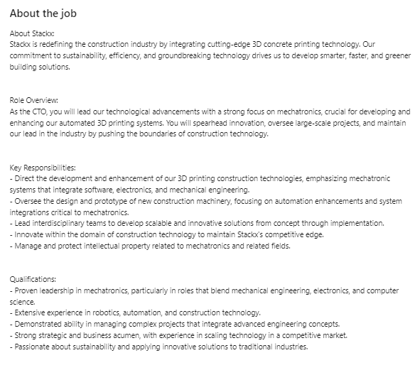

Growth Stage: Critical Impact
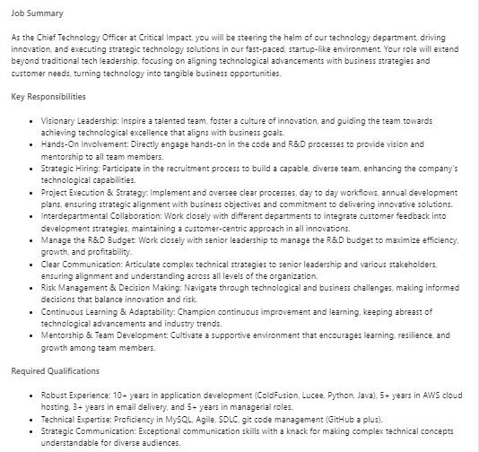

Maturity Stage:Teikametrics
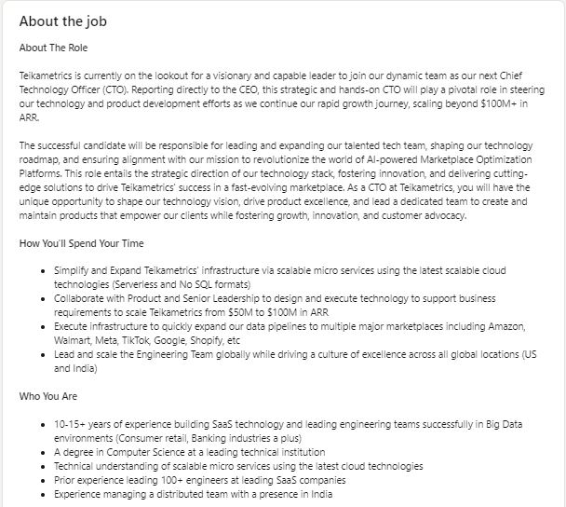

Wrapping It Up: Your CTO Solutions with 6PM
Finding the right tech leader for your company is like searching for a needle in a haystack. You're looking for someone who's not just a thinker but a doer who can dream up the future of your tech and then make it happen stat. That's where the magic of 6PM steps in, offering a silver bullet for your CTO hiring woes.

With 6PM, you're not just getting a service; you're getting a partner in tech greatness. Whether you need a part-time, full-time, or on-demand CTO, 6PM matches you with a tech advisor who's all in on taking your business to the next level. But it doesn't stop at planning. 6PM connects you with a global network of elite developers, ensuring your tech infrastructure isn't just built but built to excel and fast. Plus, with a keen eye on KPIs and budget, 6PM ensures every tech dollar you spend is a step closer to your ROI dreams.

Here’s how the 6PM model makes magic happen:

- Plan: Right from the get-go, we pair you with a tech advisor or CTO. Whether part-time, full-time, or on-demand, they're your guide in crafting a killer tech strategy. Together, you'll map out the tech landscape, pinpointing exactly what you need to succeed.
- Execute: Next up, we're putting pedal to the metal. Leading your high-velocity remote team, we're all about building robust tech infrastructure fast. With our network of top-tier developer partners, we ensure your build is speedy and smooth.
- Scale: And when it comes to growth? We've got your back. By setting precise KPIs, we keep a sharp eye on your tech budget, making sure every dollar spent is a dollar that brings you closer to your ROI goals.

So, why settle for the usual struggles when you can step up with the 6PM model? Dive into a world where tech team building is demystified, and every step you take is a step toward success. Ready to revolutionize your approach and truly capitalize on global talent? Let’s make it happen with the 6PM model. Your journey to tech excellence starts here! This conclusion aims to be engaging and persuasive, encouraging readers to consider the 6PM model as a comprehensive solution to the challenges of building and managing a tech team.

Contact Us
hello@6ppmGlobal.com
www.6pmGlobal.com

